p



Dear Parents and Students,

We would like to inform you that SAIS-Dubai will be holding its Fourth Annual Math Fair (2015-2016). The math fair will take place in the school gymnasium and the date will be announced later.

In this Fair, students from grade 6 to 12 will present math research papers and display projects that illustrate their understanding for the math topics they have covered during the academic year 2014-2015 or new topics to be covered during the current academic year. Their work will be evaluated on the basis of innovation, creativity and Knowledge of the topic they are presenting.

Our main goal behind this fair is to strengthen the research and problem solving/critical thinking skills.

The event will be an opportunity for all students to relate the abstract math theories to real life application. This process will also help our students gain a depth of understanding where they can see mathematical theories from more than one angle.

The project consists of 4 phases and the project will be worth 15% of the math term mark.

**Some clarifications:**

* Students will be evaluated when they submit their ideas and explain them until they finish all the phases.
* Each student should provide a folder to collect the phases’ reports which will be submitted on the due date of each phase after the reports are corrected.
* Each folder should include a cover page, table of contents, a bibliography and any additional required material.
* **All students will have to sit for a term exam by the end of term 1.**

Please check the table below for each phase’s description, due date, and allocated marks:

|  |  |  |  |  |
| --- | --- | --- | --- | --- |
| **Student Name:** | | | | |
| PHASE | DESCRIPTION | DUE DATE | MARKS | Teacher’s signature |
| 1  **Choosing the Topic** | * Select an idea for your project and the materials you intend to use. * Describe the process of creating and displaying your products. | Week 9  Thursday, Oct.9, 2015 | /15 |  |
| 2  **Project Report and research** | * The report should be minimum 10 A4 pages with : “TIMES NEW ROMAN FONT 12” * Cover page: Project Title, Full Name. * Outline: plan of the project * Introduction: Explaining why did you choose this project and how is it related to real life. * Hypothesis: Is the target you want to reach (proving a formula, making a conclusion out of a survey or study etc…). * Data and Analysis: Should include formulas, pictures, graphs etc… * Conclusion: What did you conclude * Acknowledgement: Address all people who helped you to do the project. * References: Include all the sources of the information you use like the name of the book, website , magazine etc….(Please include more than 2 references) | Week 12  Sunday, Nov. 15, 2015 | /40 |  |
| 3  **Class Presentation** | * Power point presentation is a PLUS. * Podcast is a plus * The teacher will assign the date of the presentation after Phase 2 | Week 13 | /30 |  |
| 4  **Project Display** | * Project Display (Math Fair) * Students should present a board with specific dimensions | To be announced later | /15 |  |

**Note**: Each day delay for every phase results in deduction of 10 % of the phase.

Marks will be deducted in case of plagiarism – and Ghost writing.

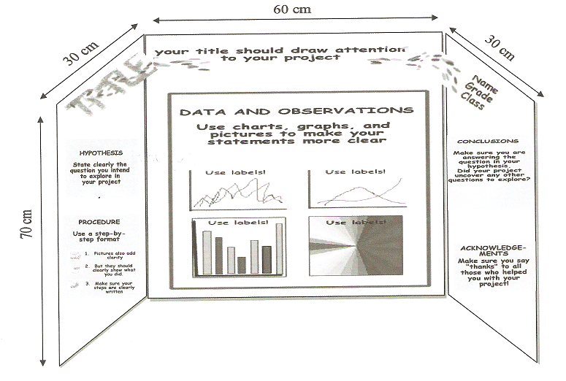**Display contents and Measurements:**

**Project Rubric**

|  |  |  |  |  |  |
| --- | --- | --- | --- | --- | --- |
|  | 4 (Exceeds Standards) | 3 (Meets Standards) | 2 (Below Standards) | 1 (Poor) | Score |
| Display | Display is attractive and well organized, does an outstanding job of catching kids’ attention and letting them know what the topic is | Display is reasonably attractive and organized, does an good job of catching kids’ attention and letting them know what the topic is | Display is not very attractive or is weakly organized; while it can be determined what the topic is, it takes some effort in viewing the display for the visitor to determine the subject of the presentation. | Display is sloppy and poorly organized, does not catch kids’ attention and/or is unclear about what the topic is |  |
| Presentation | The presentation demonstrates that the group is highly organized and has practiced the presentation; the group demonstrates enthusiasm for their topic that rubs off on the children; the group knows exactly what to say and when; the presentation makes good use of time and is exciting for the intended audience. | The presentation demonstrates that the group is organized and has practiced the presentation; the group does demonstrates enthusiasm for their topic that rubs off on the children; the presentation makes good use of time and is appropriate for the intended audience. | The presentation demonstrates some planning but could use more planning and rehearsal; it does not convey enough enthusiasm for their topic; the presentation does not demonstrate good time management; it does not hold the attention of much of the intended audience. | The presentation is not organized and possibly demonstrates a lack of preparation; the group’s presentation does not demonstrate enthusiasm for their topic; the presentation is not well planned for use of time; it does not hold the attention of the majority of the intended audience. |  |
| Mathematical Emphasis | The project demonstrates a strong link to a stated mathematical topic; it is clear to the audience what mathematical topic is behind the project; the group demonstrates a good understanding of the mathematics | The project demonstrates a link to a stated mathematical topic; it is clear to the audience what mathematical topic is behind the project; the group demonstrates understanding of the mathematics | The project demonstrates some link to a mathematical topic but it may not be clear to the audience what it is; the group demonstrates some understanding of the mathematics | The project demonstrates little or no link to a mathematical topic; it is not clear to the audience what mathematical topic is behind the project; the group demonstrates little or no understanding of the mathematics |  |
| Handouts | Handouts are well-suited for the project; serve as excellent follow-up to the ideas presented; there is a high likelihood that children will place high value on the handouts given and  do something with them after the fair is over. | Handouts are suited for the project; serve as follow-up to the ideas presented; there is a likelihood that children will place value on the handouts given and  do something with them after the fair is over. | Handouts are somewhat appropriate for the project or are weakly related to the topic; they do serve as follow-up to the ideas presented but the children will probably not value the handouts given. | Handouts are not appropriate for the project or are off the topic; they do not serve as follow-up to the ideas presented; the children will probably not value the handouts given |  |

Useful websites to find ideas:

<http://www.sciencebuddies.org/science-fair-projects/Intro-Math.shtml>

<http://mathforum.org/teachers/mathproject.html>

<http://sms.math.nus.edu.sg/Talks/Project%20Workshop%202006/CSK_slides.pdf>

<http://hrsbstaff.ednet.ns.ca/tmcclare/mathprojectideas.htm>